**School :** Computer Science

**Institution :** University of Windsor

**Term :** Fall 2021

**Course :** Comp-3150 (03-60-315-1) : Database Management Systems

**Instructor :** Dr. C. I. Ezeife

**Assignment #**2 : Total : 50 marks

**Handed Out: Thurs. Sep. 30, 2021; Due Thurs. Oct. 28, 2021**

**Objective of Assignment**: To test on knowledge and design of relational model constraints, relational database schemas, functional dependencies and normalization of relational databases.

**Scope**: Assignment covers materials from Chapters 5 and 14 of book discussed in class.

**Electronic Assignment Submission:** Done through <http://blackboard.uwindsor.ca>

**Marking Scheme** : The mark for each of the questions is indicated beside each question.

**Academic Integrity Statement** : Remember to submit only work that is yours and include the following confidentiality agreement and statement at the beginning of your assignment.

**CONFIDENTIALITY AGREEMENT & STATEMENT OF HONESTY**

**I confirm that I will keep the content of this assignment/examination confidential.**

**I confirm that I have not received any unauthorized assistance in preparing for or doing this assignment/examination. I confirm knowing that a mark of 0 may be assigned for copied work.**

Ravi Trivedi Ravi Trivedi

Student Signature Student Name (please print)

105197609 24th October, 2021

Student I.D. Number Date

**Marking Scheme : The mark for each question and sub question is shown with the question below. Place your solutions in tables where possible.**

**For office Use only**

|  |  |
| --- | --- |
| **Question** | **Mark** |
| **1** | **/20** |
| **2** | **/10** |
| **3** | **/10** |
| **4** | **/10** |
| **Total** | **/50** |

**CHAPTER 5: THE RELATIONAL DATA MODEL AND RELATIONAL DATABASE CONSTRAINTS**

1. (total marks 20) Given the same simple Person-Vaccinatedin-Centre database schema that contains three files described as follows, answer the following questions with regards to this database.   
    (Total for que 1 is 10 marks)

Person (Ssn: integer, Name: string, Age: integer, jobtype: string)

Vaccinatedin (Ssn: integer, Cntid: integer, vacdate:date, dose: integer, time: real)

Centre (Cntid: integer, Cntname: string, city: string, budget: real, managerid: integer)

Note: Ssn, Name, Age, jobtype are the social security number, name, age and job type respectively. Also, Cntid, vacdate, dose and time represent centre id, vaccination date (e.g., in dd-mon-yy), which dose (1 or 2) and vaccination time (e.g., 0.00 is 12.00am and 12.00 is 12.00pm at noon). The rest of the attributes Cntname, city, budget and managerid are the centre name (eg. WFCU, St Clair, DownTown, Other), city, budget for running the centre (eg. $80,000) and managerid respectively. A manager is a Person. A manager (e.g., with managerid same as an SSN) is a person who manages the vaccination centre.

Assume that an update operation (a general term in this chapter, for an insert, a modify or a delete operation) is to be made to this database to enter information about a new person not already in the database but who has just been vaccinated in a centre. Answer the following questions on what specific relations, attributes and operations (eg. insert, modify, delete) that need to be done for this update to be implemented in the entire database. This is not SQL query yet.

Provide your answers both in descriptive sentence and using the formal (not SQL) database operations of INSERT, MODIFY, DELETE as used in Chapter 5 of book with specific attributes and relations when possible. An example formal insert of a peson record into the Member table is:   
INSERT < Ssn, Name, Age, jobtype> into Person // for new Person record

And an example descriptive sentence is:   
i). do an insert operation for a new person record into the Person table.

(a) Give the set of needed insert, modify or delete operations for this update operation scenario described above. 5 marks

(b) What types of integrity constraints (explain using attributes, eg, SSN of relevant files) would you expect to check for this update to be done? 5 marks

(c) Which of these integrity constraints are key, entity integrity, and referential (foreign key) integrity constraints and which are not? 5 marks

(d) Specify all the referential integrity (foreign key) constraints on this database in the format Referring_Relation.Attribute --> Referred_Relation.Attribute. 5 marks  
 (Total for que 1 is 20 marks)

Solution:

|  |  |
| --- | --- |
| **Question** | **Answers** |
| a. Give the operations for this update.  5 marks | INSERT < Ssn, Name, Age, jobtype > into Person  : do an insert operation of a new person record to the Person table  INSERT < Ssn, CntId, VacDate, Dose, Time> into Vaccinatdin  : do an insert operation of a new vaccinated person record to the Vaccinatedin table |
| b. What types of integrity constraints would you expect to check? (explain using attributes, eg, SSN of relevant files)  5 marks | Person INSERT   * Check if Ssn already exist or unique in the db, and * Check if all the given data is correct, i.e. name as a string, age as an integer, jobtype as a string   Vaccinatein INSERT   * Check if Ssn already exist in the Person table * Check if CntId exist in the Centre table * Check the date format of VacDate * Check if the dose is between 0 and 2 * Check the given time format |
| c. Which of these integrity constraints are key, entity integrity, and referential integrity constraints and which are not?  5 marks | Key   * Ssn in Person * {Ssn, CntId} in Vaccinatedin * {CntId, CntName} in Centre   Entity Constraints   * Ssn in Person has to be unique. * CntId in Centre has to be unique.   Referential Integrity Constraints   * Ssn and CntId in Vaccinatedin has to be in the both table. (Ssn from Person and CntId from Center) |
| d. Specify all the referential integrity constraints on this database.  5 marks | We will write a referential integrity constraint as R.A --> S.A (or R.(X) --> T.A) whenever attribute A (or the set of attributes X) of relation R form a foreign key that references the primary key of relation S (or T). |

1. (total marks 10) Using your own Person-Vaccinatedin-Centre database instance from assignment 1, login to the SQL query processor on our cs server, called Oracle Sqlplus to create the three database tables and insert the tuples in your database state with the following sequence of instructions. Note that this exercise is to get you beginning to connect to SQLplus while preparing to learn full SQL language syntax in Chapters 6 and 7. You will be given the instructions to use now. Show the result of this exercise through a Unix script file you will attach as a .txt file.

(Total for que 2 is 10 marks)  
  
i. First connect to our cs.uwindsor.ca through either Bitvise SSH client or NoMachine

ii. Then hand in a Unix script file to capture your Unix session when you connect to Sqlplus after your instructions for creating your database are working. You can create your Unix script file using the following sequence of instructions on a Unix terminal on our cs server. You need to transfer this script file to your personal computer using a file transfer protocol (eg. Bitvise SFTP or Filezilla) in order to attach it in your assignment submission.

>script username_assn2que2.txt  
>sqlplus <username>  
>password   
  
SQL> CREATE TABLE PERSON(

SSN NUMBER(3) NOT NULL,

NAME VARCHAR2(15),

AGE NUMBER(3),

JOBTYPE VARCHAR2(15),

PRIMARY KEY(SSN));

SQL> CREATE TABLE CENTRE

(

CNTID NUMBER(3) NOT NULL,

CNTNAME VARCHAR2(15) NOT NULL,

CITY VARCHAR2(15),

BUDGET NUMBER(10,2),

MANAGERID NUMBER(3),

PRIMARY KEY (CNTID),

FOREIGN KEY(MANAGERID) REFERENCES PERSON(SSN));

SQL> CREATE TABLE VACCINATEDIN(

SSN NUMBER(3) NOT NULL,

CNTID NUMBER(3) NOT NULL,

VACDATE DATE,

DOSE NUMBER(3),

VACTIME NUMBER(6,2),

PRIMARY KEY(SSN, CNTID),

FOREIGN KEY(SSN) REFERENCES PERSON(SSN),

FOREIGN KEY(CNTID) REFERENCES CENTRE(CNTID));

-- insert of a record from A1 into Person table

INSERT INTO PERSON VALUES (123, 'Ravi', 20, 'Developer');

INSERT INTO PERSON VALUES (345, Abir', 19, 'Sales Rep');

INSERT INTO PERSON VALUES (678, 'Bingo', 24, 'Gamer');

INSERT INTO PERSON VALUES (009, 'Marq', 48, 'Plumber');

-- insert of a record from A1 into Centre table

INSERT INTO CENTRE VALUES(0010, 'WFCU', 'Windsor', 75000, 123);

INSERT INTO CENTRE VALUES(0011, 'St Clair', 'Windsor', 25000, 345);

INSERT INTO CENTRE VALUES(0012, 'DownTown', 'Windsor', 120000, 678);

INSERT INTO CENTRE VALUES(0013, 'WRH', 'Windsor', 150000, 009);

INSERT INTO VACCINATEDIN VALUES (10, 1, '02-apr-21', 1, 13.30);  
  
SQL> COMMIT;

// Repeat similar INSERT instructions for all the data in all your tables

// starting with the entity tables first, eg, Person, Centre, before VACCINATEDIN.

SQL> select * from cat; // to show all the objects in your catalogue

SQL> select * from Person; // to show the contents of this table

SQL> exit //to exit sqlplus

>exit // to exit and create Unix script file to hand in

** More Hint: While in Sqlplus, if you want to delete data from your tables and drop them before issuing your instructions for creating your Unix script file for handing in, you can use the following instructions for each table to first delete the data from the table and then drop the table.

delete from VACCINATEDIN;  
delete from PERSON;  
delete from CENTRE;

commit;

drop table VACCINATEDIN cascade constraints;

drop table PERSON cascade constraints;

drop table CENTRE cascade constraints;

commit;  
***  
  
Also Note: you can start creating a script file only after you have created your tables correctly and inserted data in the tables. In that case, you cannot re-create existing tables. Then, you can just run the desc table (eg. Desc Person) command for each table to show the structure of each table before using (for example), the (select * from Person;) to show the tuples of each table or delete data and drop the tables as explained above so you can re-create the tables more correctly.

Solution: (10 marks)

|  |
| --- |
| An attached Unix script file showing execution of CREATE TABLE instructions and INSERT INTO tablename VALUES instructions with the few SELECT instructions to show contents of the catalogue and all tables (your database instance). |

**CHAPTER 14: Database Design Theory: Introduction to Normalization Using Functional and Multivalued Dependencies**

**3.** (total marks 10) Consider the following relation:

Enrolled(Studid, Crsid, SName, Score, Lettergrade)

Assume that a student (Studid) may be enrolled in multiple courses (Crsid) and hence {Studid, Crsid} is the primary key.   
Thus, the following functional dependency exists:

{Studid, Crsid} -> {SName, Score, Lettergrade}

Additional dependencies are:

Studid -> SName

Score -> Lettergrade

Based on the given primary key,

1. is this relation in 1NF, 2NF, or 3NF? Why or why not?
2. If not in 2NF at least, normalize it completely into 2NF and 3NF? Provide your answers using functional dependencies (FDs). (Total for que 3 is 10 marks)

Solution (i): (5 marks)

|  |
| --- |
| ***Answer:***  Given the relation schema  Enrolled(Studid, Crsid, SName, Score, Lettergrade)  with the functional dependencies  {Studid, Crsid } -> {SName, Score, Lettergrade}  Studid -> SName  Score -> Lettergrade   1. is this relation in 1NF, 2NF, or 3NF? Why or why not? |

Solution (ii) (5 marks)

|  |
| --- |
| If not in 2NF at least, normalize it completely into 2NF and 3NF? Provide your answers using functional dependencies (FDs). |

**4.** (total marks 10) What (i) update, (ii) delete and (iii) insertion anomalies occur in the DEPARTMENT_PROJECT relation obtained by doing a natural join of the two relations DEPARTMENT and PROJECT of Fig 14.2 on page 463 of book? Explain with examples using this database and the DEPARTMENT_PROJECT relation schema with state given below as Figures 4.1 and 4.2 below. (Total for que 4 is 10 marks)  
Note: 3 marks for correct discussion of each anomaly and 1 mark for attempt.

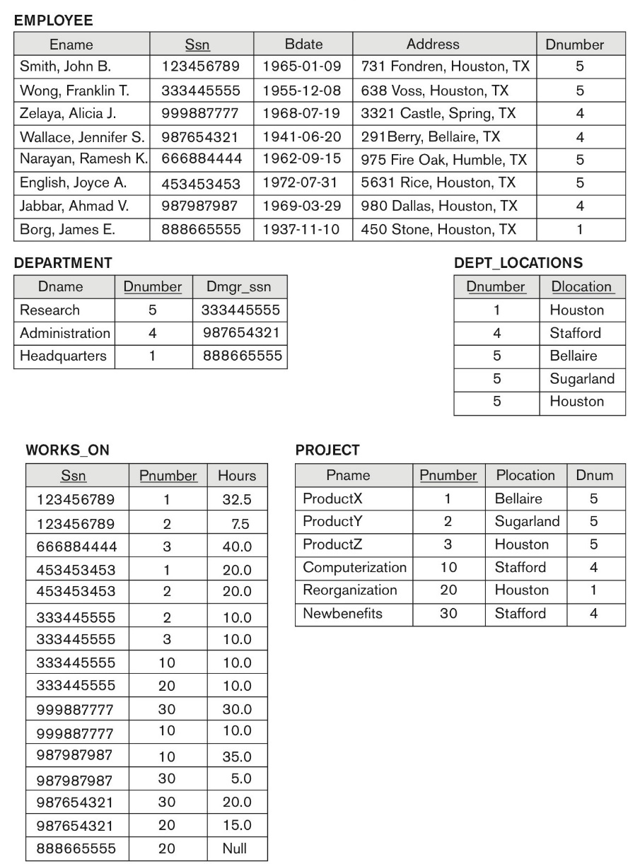

**Figure 14.2 (book):** Sample database state for a simplified COMPANY relation DB

****

Fig 4.1: DEPARTMENT_PROJECT DB schema suffering from update anomalies

FD1

FD2

FD3

Dnumber Pnumber Dname Dmgr_ssn Pname Plocation

***

Fig 4.2: A database state of the DEPARTMENT_PROJECT DATABASE derived from Fig 14.2

DNUMBER PNUMBER DNAME DMGR_SSN PNAME PLOCATION

---------- ---------- --------------- --------- --------------- ---------------

5 3 Research 333445555 ProductZ Houston

5 10 Research 333445555 Computerize Stafford

5 20 Research 333445555 Reorganize Houston

5 30 Research 333445555 Nbenefits Stafford

5 1 Research 333445555 ProductX Bellair

5 2 Research 333445555 ProductY Sugarland

4 3 Administration 987654321 ProductZ Houston

4 10 Administration 987654321 Computerize Stafford

4 20 Administration 987654321 Reorganize Houston

4 30 Administration 987654321 Nbenefits Stafford

4 1 Administration 987654321 ProductX Bellair

4 2 Administration 987654321 ProductY Sugarland

1 3 Headquarters 888665555 ProductZ Houston

1 10 Headquarters 888665555 Computerize Stafford

1 20 Headquarters 888665555 Reorganize Houston

1 30 Headquarters 888665555 Nbenefits Stafford

1 1 Headquarters 888665555 ProductX Bellair

1 2 Headquarters 888665555 ProductY Sugarland

18 rows selected.

Solution: (3 + 3 + 3 + 1 marks)

|  |
| --- |
| 1. Update Anomalies: 2. Delete Anomalies: : 3. Insertion anomaly: |